**Names: klinsman kengne**

**ID:24042**

Web Technology Final Project Guideline

**Title: Medical Management System Application**

**Introduction**

The Medical Management System Application is a system that can help health center, Hospitals or any other health related sectors to **diagnose patient** according to the **symptoms** i.e. when inserting a patient to the system it has to decide the exact disease that such patient is having according to the specified symptoms.

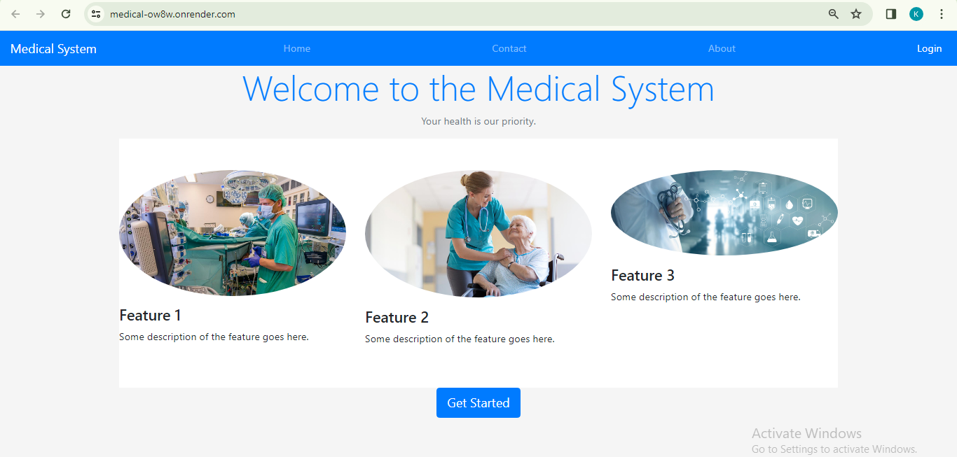

**Project requirement**

* For a one to use the system they should have an account (They must sign up).

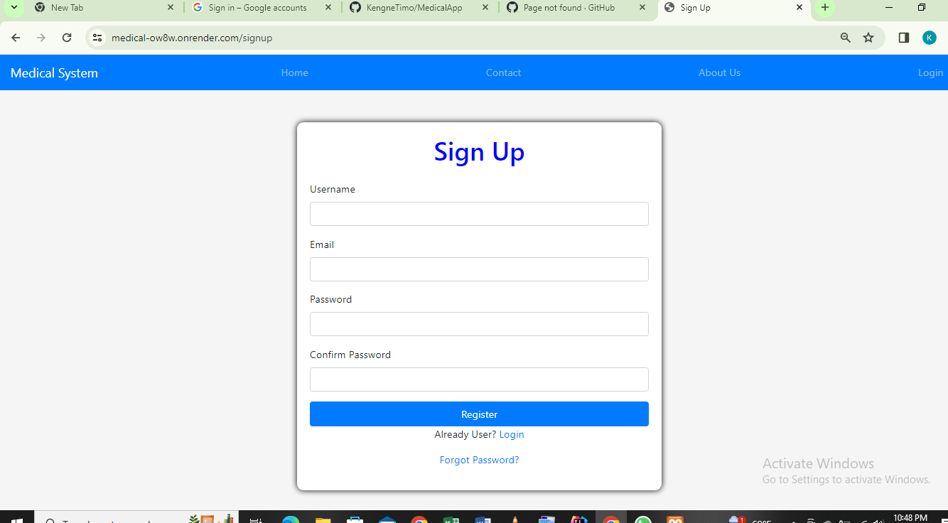

* When signing up password is validated that it and its confirmation must match otherwise the error message is raised showing a one what should be done.
* The same to email field also its validated.

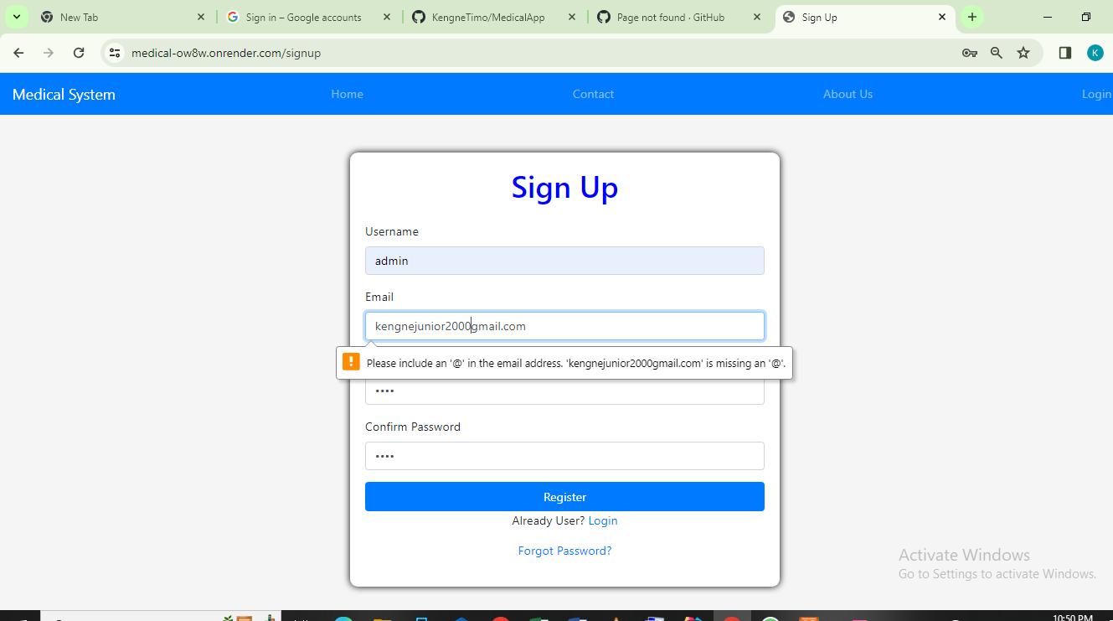

* When logging in to the system also inputs are validated and authorized

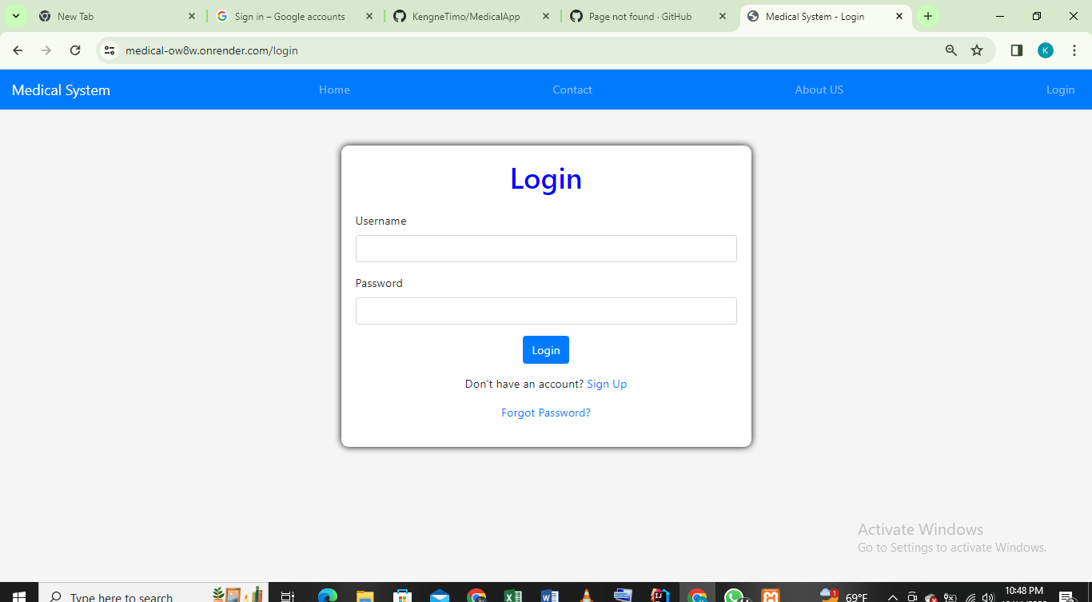

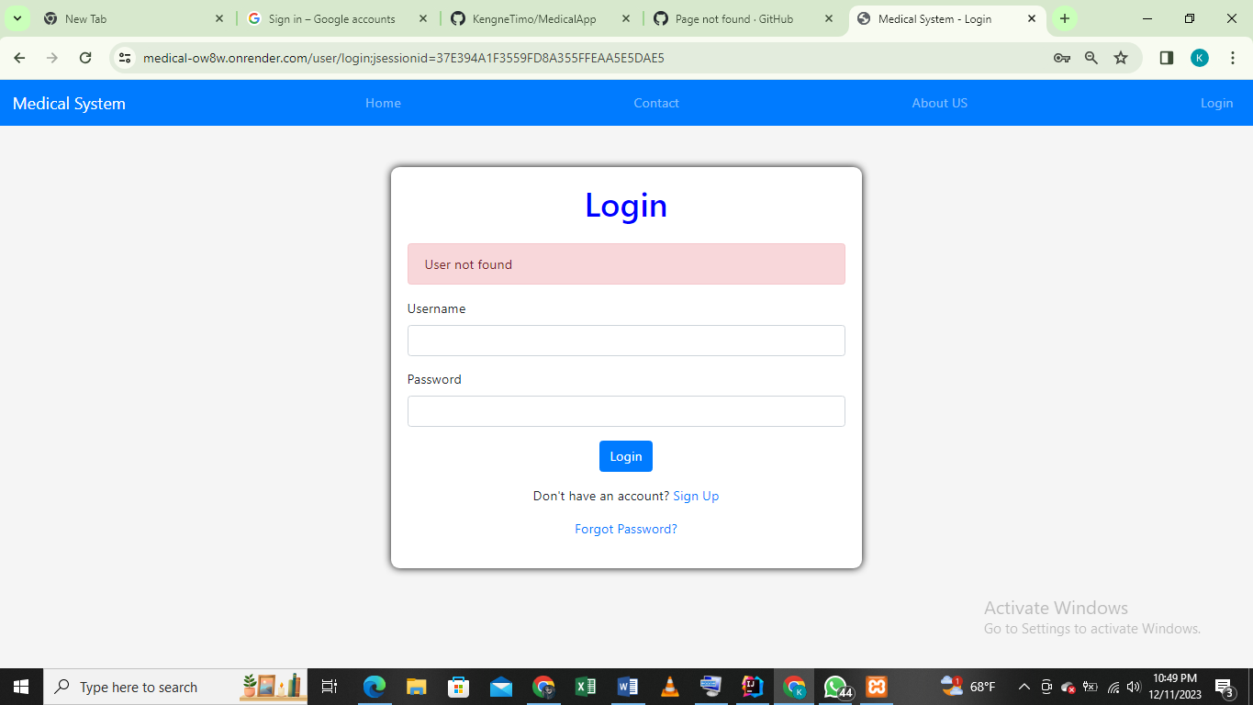

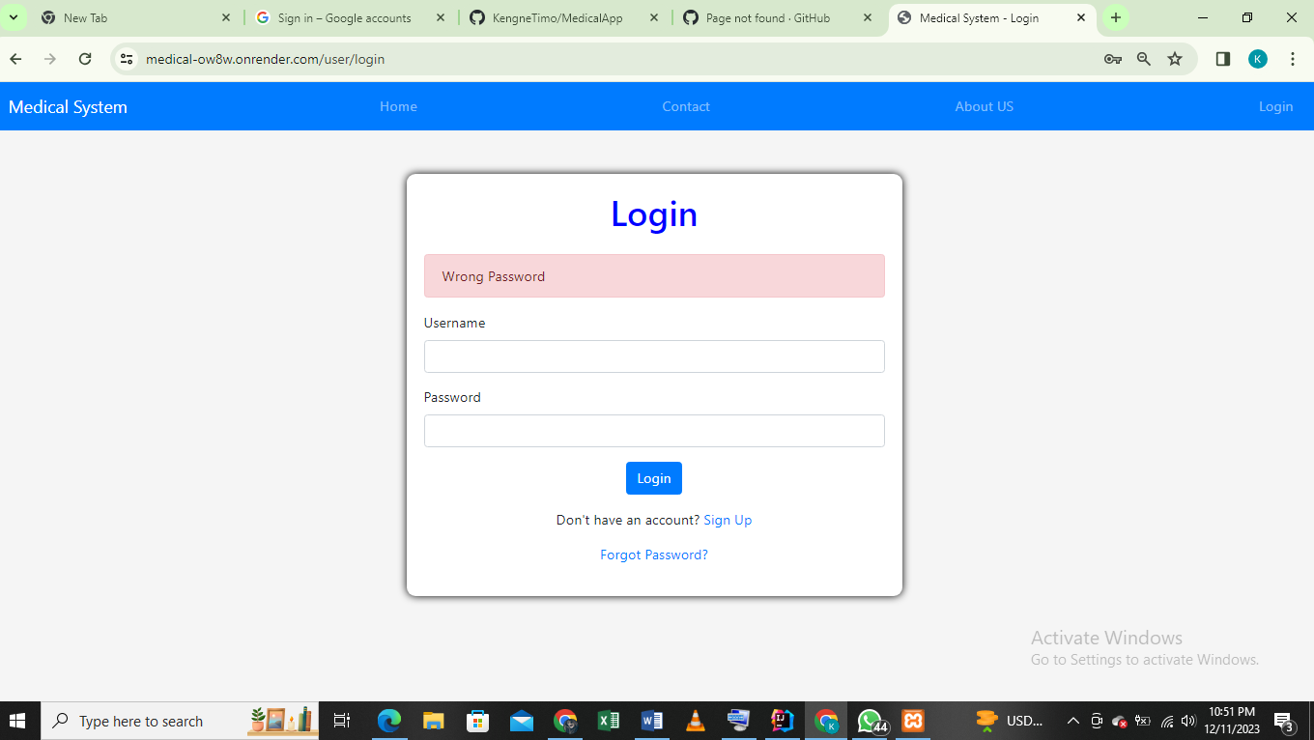

* When a user has signed in and after logging in the system redirect them to the dashboard according to role.

1. If logged in as **“admin”** then must lead to the admin dashboard

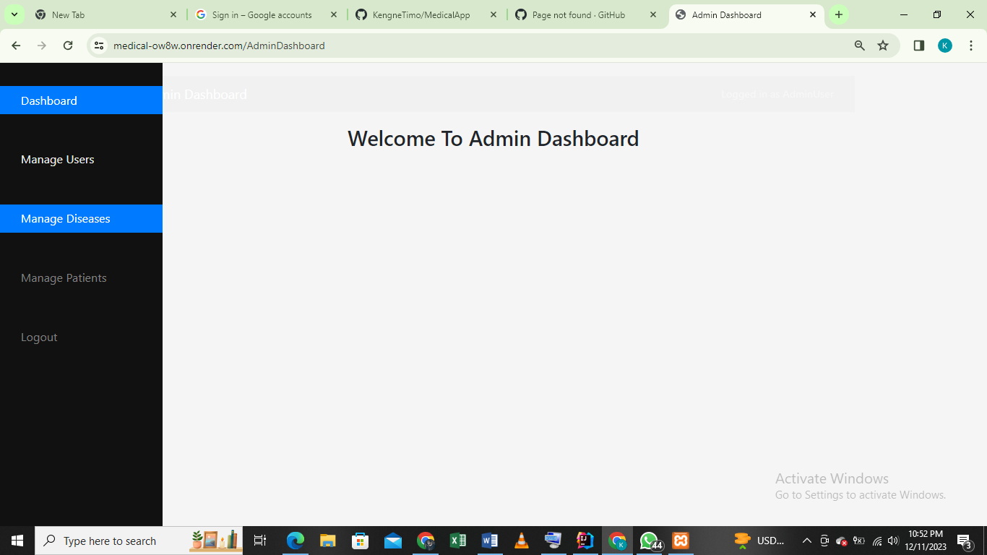

1. If logged in as other username which is not an admin then must lead to user dashboard

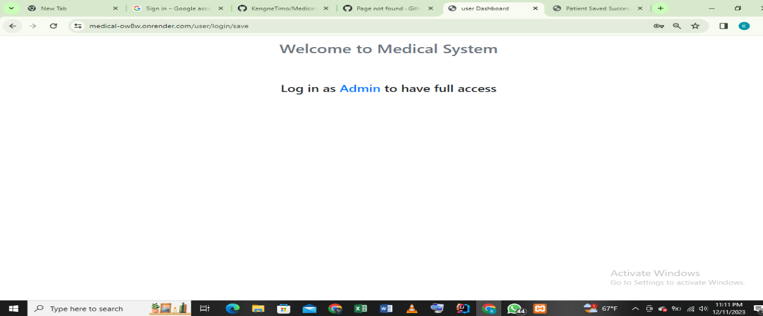

* If logged in as a normal user no other operation the logged in user should be able to perform however if logged in as an **“admin”** then different operations must be performed including:
  + Managing users
  + 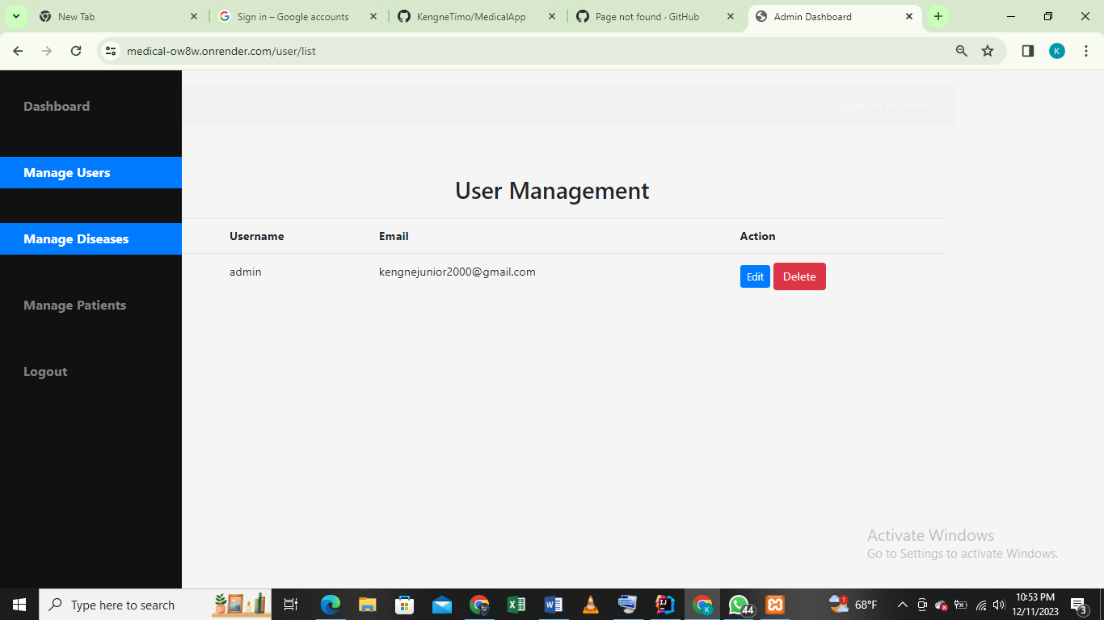
  + 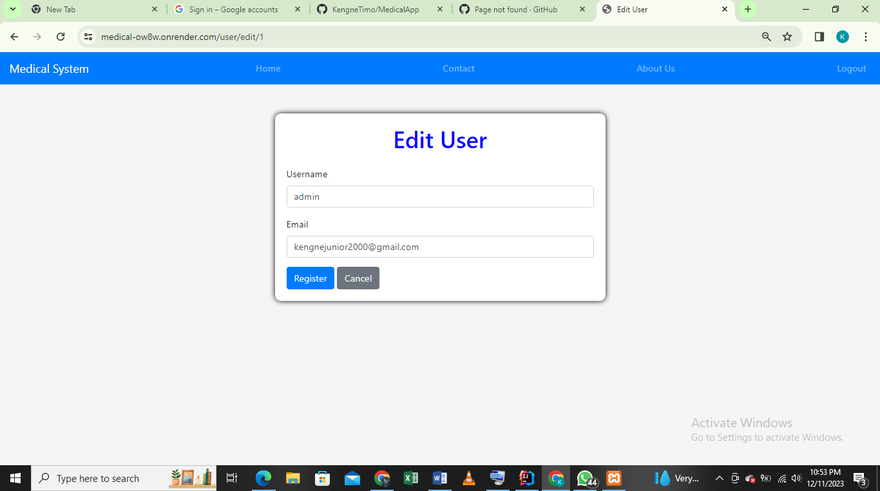
  + Managing diseases
  + 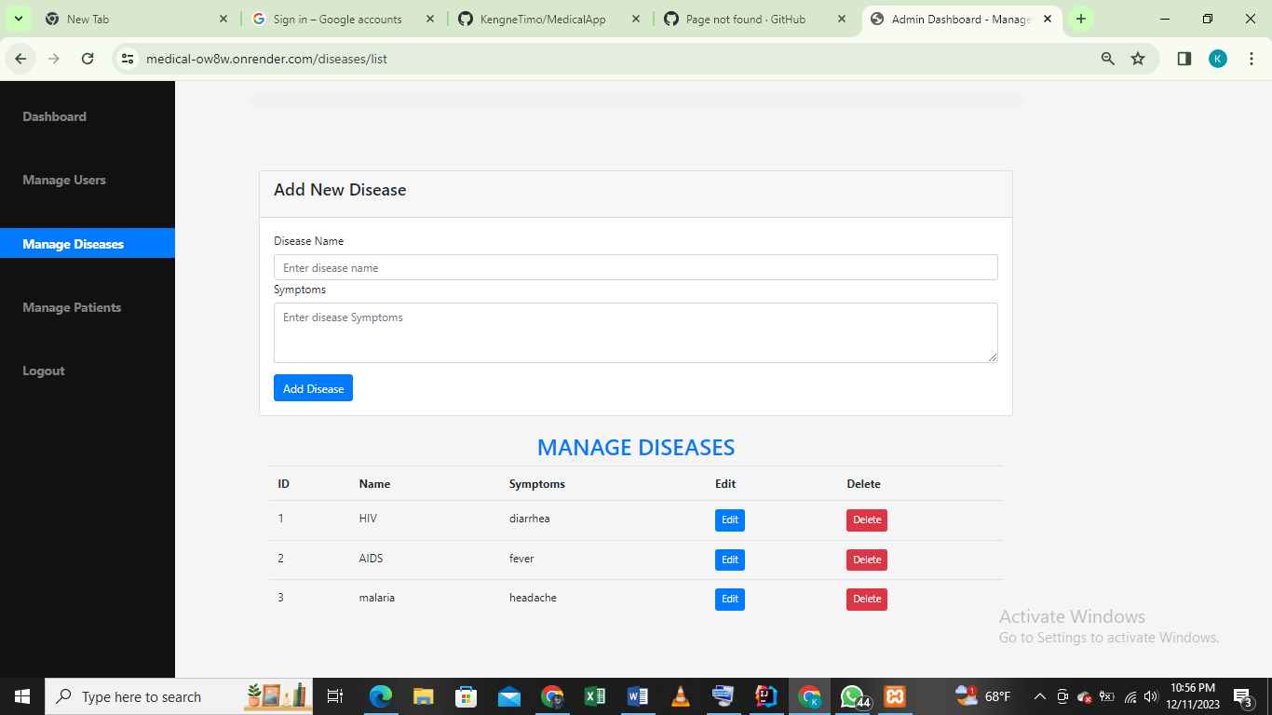
  + Manage Patients
  + 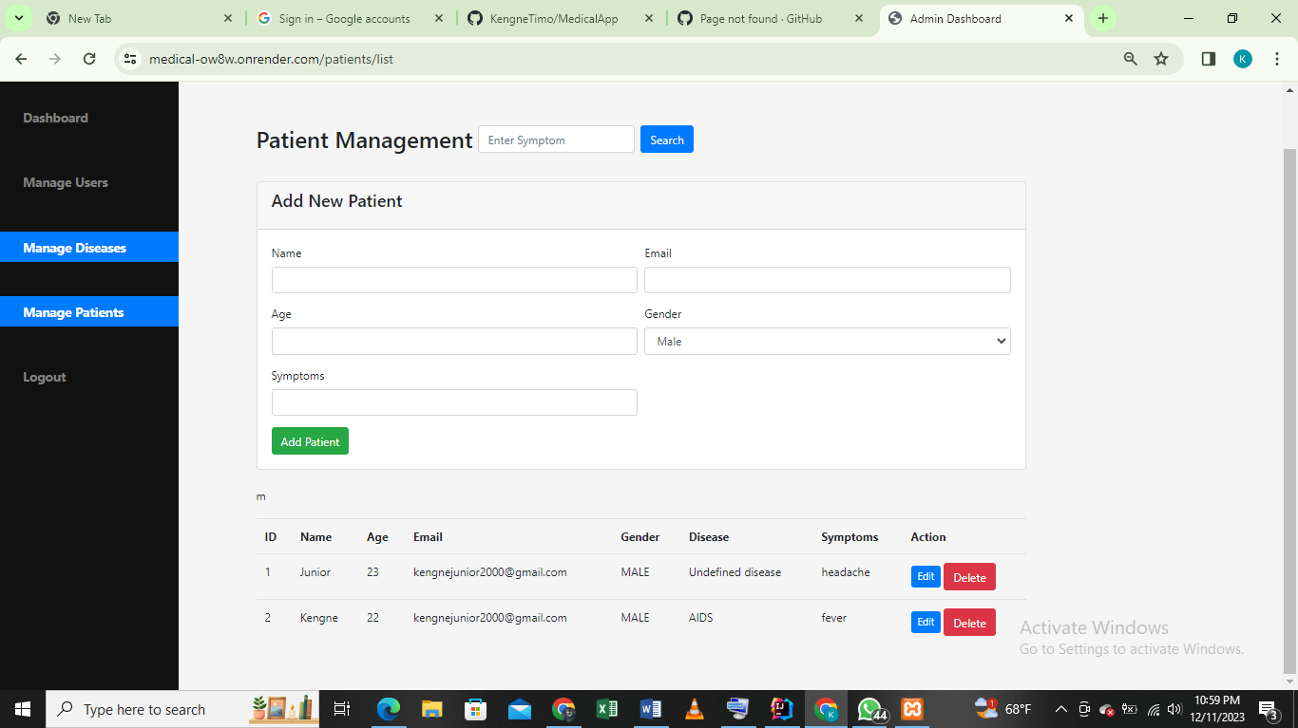
  + Search patients by **“Symptoms”**
  + 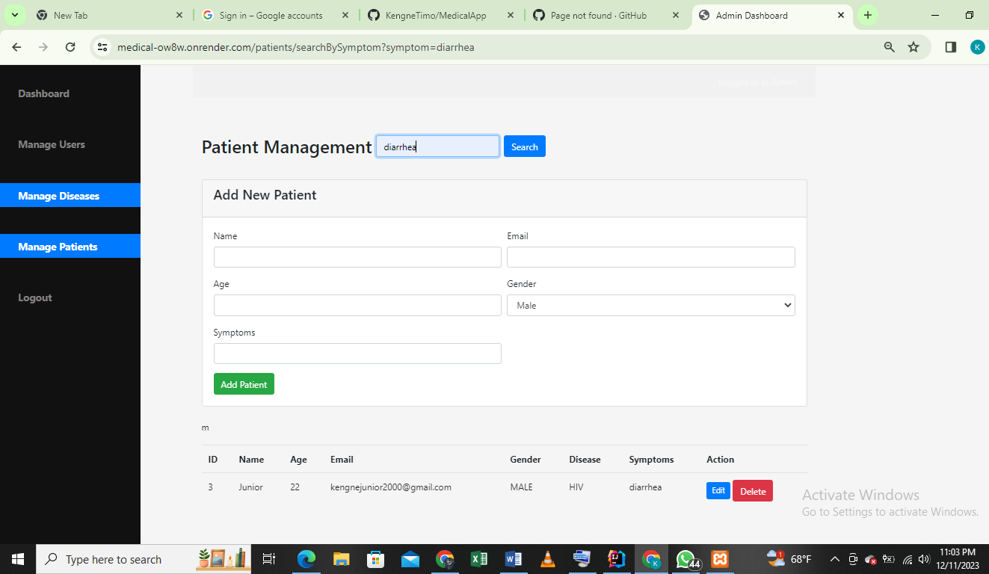

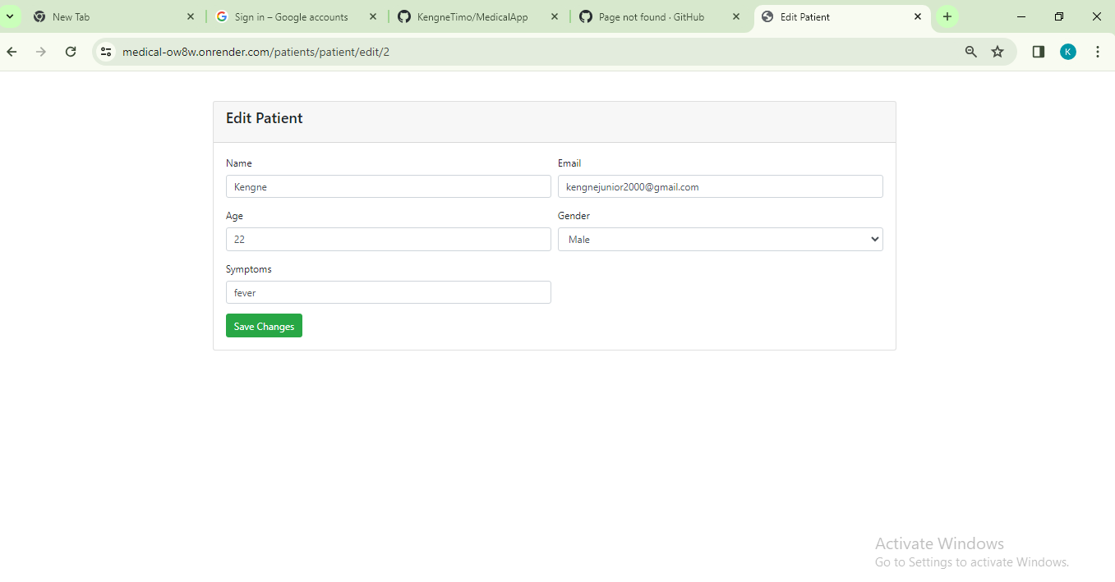

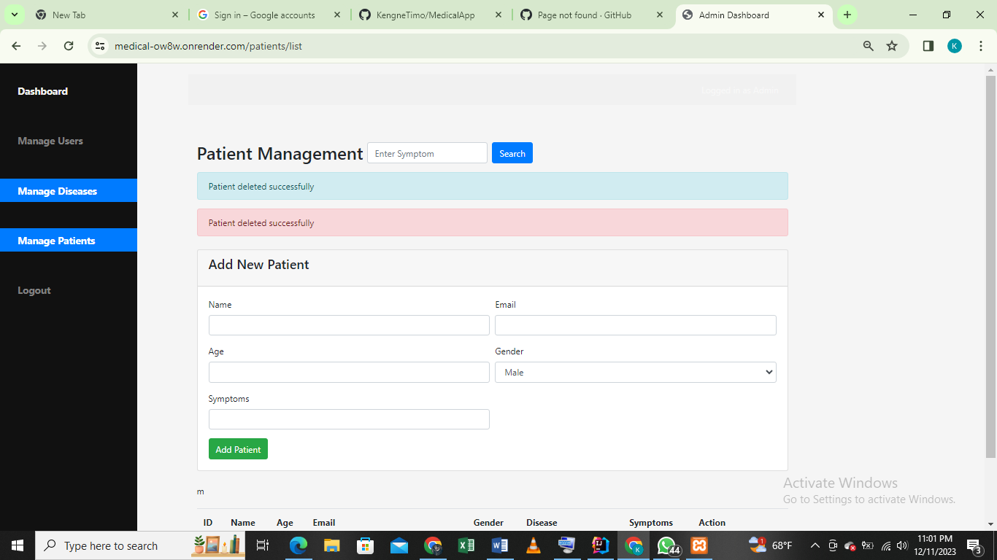

* The email is sent after every activity takes place in the system. For instances:

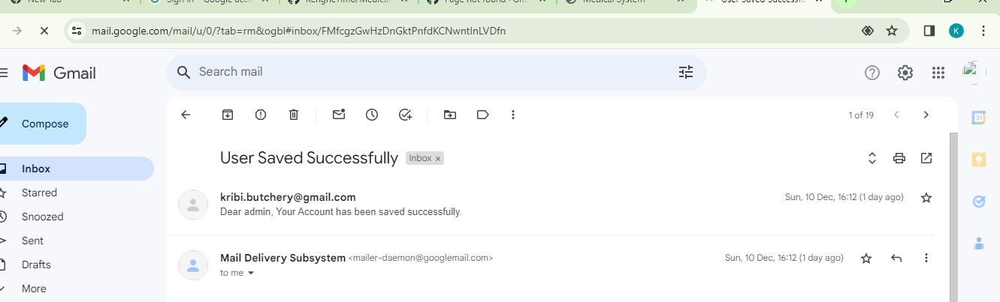

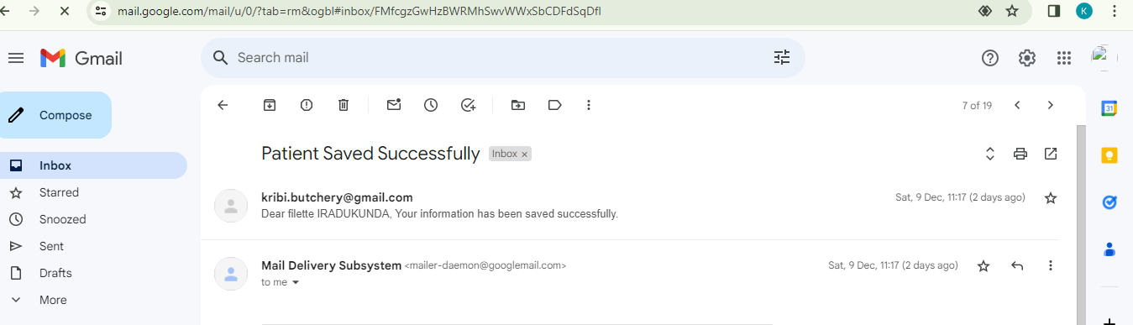

**DATABASE Entities**

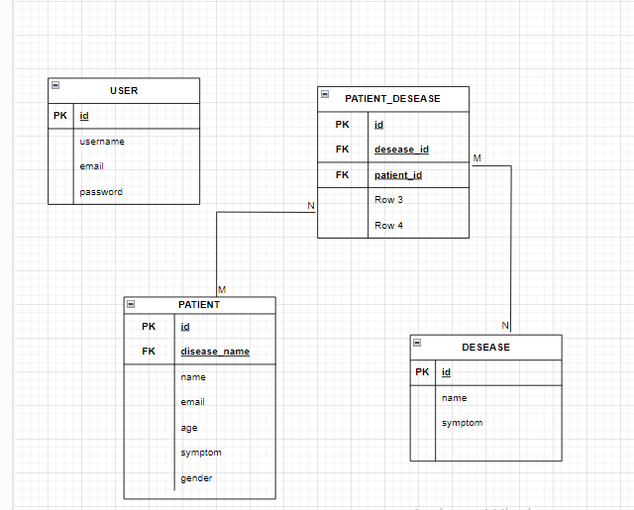

**Languages**

* + - Java
    - HTML
    - CSS
    - Java Script
    - Spring boot
    - MySQL Database
    - Maven

**NOTE:**

1. The project source codes are found on the GitHub**: https://github.com/kengneklinsman/Webtech_Final_Exam.git**

**THANK YOU!!!!!!**